
Egypt University of Informatics
Computer and Information Systems
Data Analysis Course

A Data Analysis Approach to Understanding the Effects of Fuel Price Changes on Driving Behavior in Egypt

  - Submitted by:
Khaled Elsayed 24-101268
Ammar Nabil 24-101272
Habiba Mohamed 24-101018
Joudy Badawi 24-101183

  - 10/04/2026

Introduction:
Fuel prices in Egypt have been changing a lot in recent years, affecting people’s daily lives. As prices increase, many individuals start to adjust how often they drive and rethink their transportation choices. This study explores how fuel price changes influence driving behavior, the shift to alternative transportation, and financial burden. It aims to understand whether higher fuel costs lead people to reduce their trips or experience greater financial pressure.

Research Question:
Does the increase in fuel prices in Egypt change the way people choose their transportation?

Hypothesis:
Null Hypothesis: The increase of fuel prices in Egypt does not affect people's transportation choices.
Alternative Hypothesis: The increase in fuel prices in Egypt affects people's transportation choices.

Population of Interest:
The population of interest for this study is the EUIANS specifically within the age group of 18 to 24, who are either car owners or frequent commuters.

Sampling Method:
We used Convenience Sampling to collect 54 responses from EUI students. This was the best method for our project because it allowed us to gather data quickly from our classmates. Since we all share the same daily commute to the university, their answers provide real and useful information for our study.

Bias Identification:
In this study, we identified a Selection Bias because our data comes only from university students (EUIANS). This means the results might not represent older people or different jobs. To keep the survey fair, we used very simple and neutral questions so we wouldn't influence anyone's answers. We also shared the survey with students from different majors to get a better variety of opinions.

Survey Questions:
- What is your Gender
- What is your age group
- Which fuel grade do you most commonly use?
- Approximately how many Kilometres do you drive in a typical week?
- Roughly how much do you spend on fuel per month?
- How much of a financial burden do you consider current fuel prices to be? (1 = no burden at all, 5 = very significant burden)
- Have recent fuel price increases in Egypt changed any of your driving habits?
Online survey link: https://docs.google.com/forms/d/1fbfefuYMqbGjyADt4w538J-8yGdjWECCrRGJW7dwPuA/edit?ts=69d2ca59
Number of samples collected: 54

Analysis:
To analyze the data collected from the 54 EUI students, we used data visualization and frequency analysis. We focused on identifying the most common patterns in how students spend their budget on fuel and how they perceive financial pressure. Through various charts, we aim to show how fuel price increases have directly influenced the driving behavior and transportation choices of the students by highlighting the distribution of their responses.

1.Which fuel grade do you most commonly use?
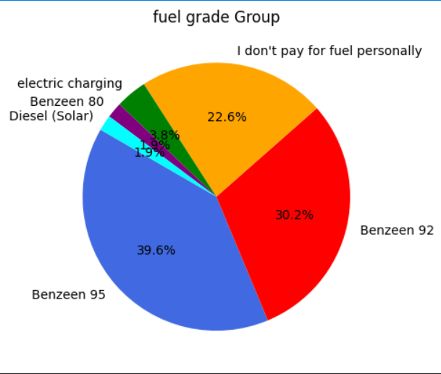

This bar chart shows the distribution of fuel grades used by the respondents. The majority of EUI students use either 92 (30.2%) or 95(39.6%) octane fuel, which are the most common choices for modern private cars.
From this data, we can see that our sample group mostly relies on higher-grade fuel. This is important because price increases in these specific fuel types will have a direct and significant impact on their monthly transportation budget.

2.Approximately how many kilometers do you drive in a typical week?

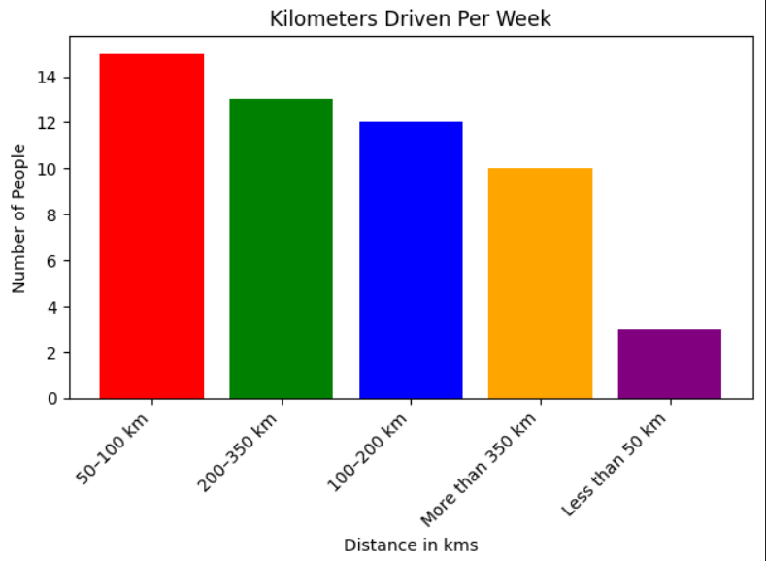

This bar chart represents the distribution of weekly kilometers driven by EUI students. The data shows that most respondents drive between 50 and 200 kilometers per week, with the 50-100 km range being the most frequent. There is also a notable group that drives more than 350 km weekly.

By looking at this data, we can understand the students’ driving patterns. Knowing the typical distance driven helps us realize how much the fuel price increases will affect their total transportation costs. Those who drive longer distances are likely to face a much higher financial impact.

3. Roughly how much do you spend on fuel per month?

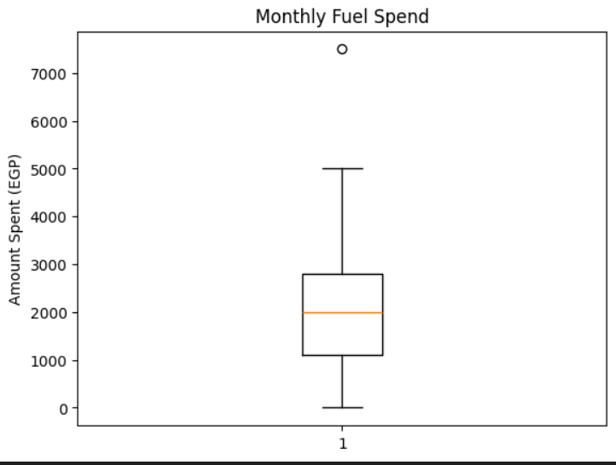

This box plot represents the distribution of monthly fuel spending among EUI students. It shows the range of expenses, with the central box representing where most students fall, and the whiskers indicating the minimum and maximum values within the typical range.

From this graph, we can observe variation in fuel costs among students. While some spend a moderate amount, there are others (outliers) who spend significantly more, with values reaching up to around 7,500 EGP. This may be due to longer commuting distances. This indicates that fuel price changes do not affect all individuals equally but instead have a greater impact on those who drive longer distances.

The mean of monthly fuel spend per months is 2082.86 EGP.
The median is 2000 EGP, indicating that most students spend around this value.
The mode is 2000 EGP, which shows that this is the most common spending level among respondents per months.
The minimum is around 0 EGP (electric charging). Lower quartile is around 1100 EGP and the upper quartile is around 2800 EGP while the maximum is approximately 5000 EGP

4.How much of a financial burden do you consider current fuel prices to be? (1 = no burden at all, 5 = very significant burden

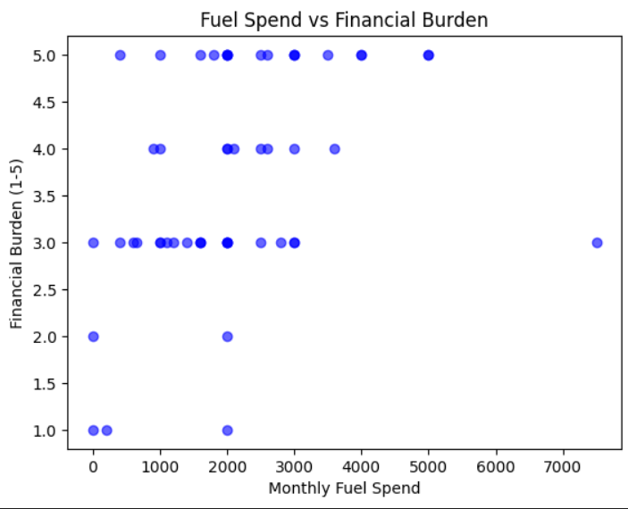

This scatter plot shows the relationship between monthly fuel spending and perceived financial burden (on a scale from 1 to 5). Each point represents an individual response.
The data indicates that higher levels of financial burden are reported across different spending levels. While some students with higher fuel spending report greater financial pressure, there are also students with lower spending who still experience moderate to high levels of burden.
This suggests that the impact of rising fuel prices is not limited to high spenders only, but is felt by a wider range of individuals.

The mean financial burden rating is 3.7 indicating a relatively high perceived burden
The median is 3.5, indicating that most students perceive the fuel prices at this level of burden
The mode is 3, which shows that this is the most common rating among respondents

5.Have recent fuel price increases in Egypt changed any of your driving habits?
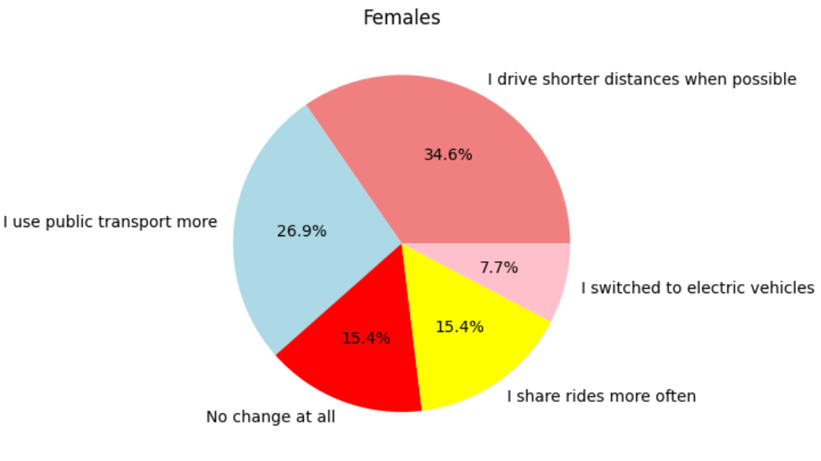
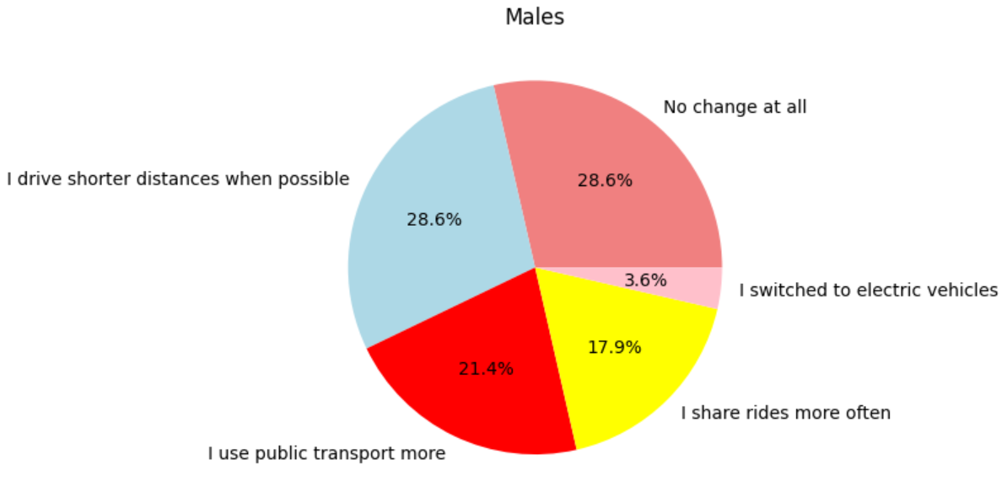
Is gender related to driving habits?

The pie charts show how male and female changed their transportation habits. It’s clear that females are more willing to change the way they drive, while males are less likely to do so. In fact, the percentage of males who made no change at all is almost double that of females.
Even though our sample is within a narrow age range (18-24), we observed slight differences in behavior between younger and older students

By looking at the data, we knew that : there is clear differences between males and females in their transportation habits. Among males, a large group (28.6%) did not change their behavior at all, and the same percentage reported driving shorter distances. Around(21.4%) started using public transport more, while (17.9%) chose ride-sharing, and only a small number (3.6%) switched to electric vehicles. On the other hand, females were more willing to adapt. The most common change was driving shorter distances (34.6%), followed by increased use of public transport (26.9%). More females also switched to electric vehicles (7.7%), which is almost double the male percentage. In addition, only (15.4%) of females reported no change, showing they are more open to changing their habits.

This table is showing the difference between males and females clearly:
Category | Males | Females | Variance/Trend
No Change at All | 28.6% | 15.4% | Males didn’t change their habits easily.
Shorter Distances | 28.6% | 34.6% | Females shortened their distances more than males.
Public Transport | 21.4% | 26.9% | Females show higher reliance on communal transit.
Electric Vehicles | 3.6% | 7.7% | Electric vehicles is owned 113% higher in the female demographic.

Does age affect driving habits ?
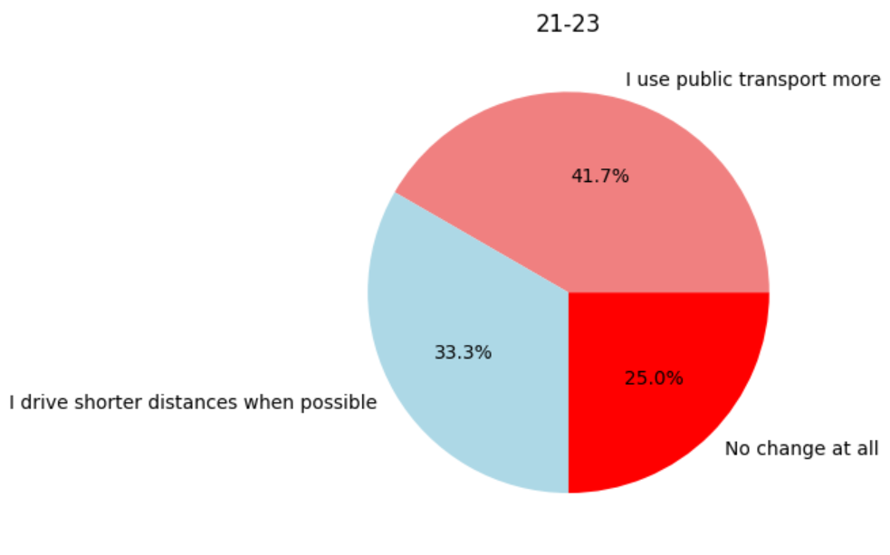
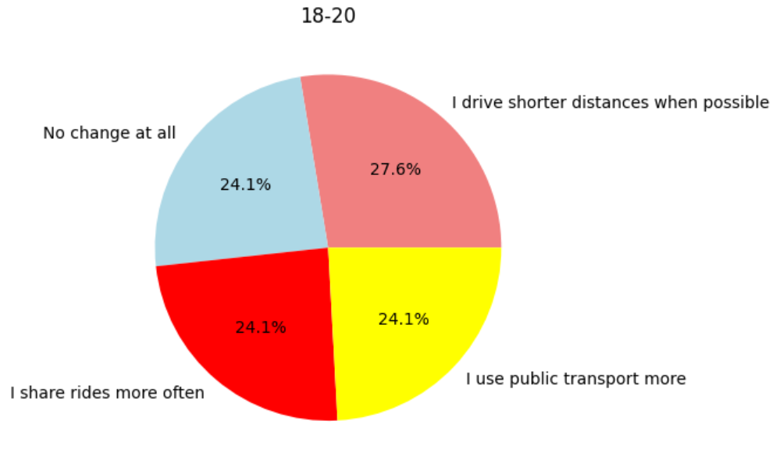
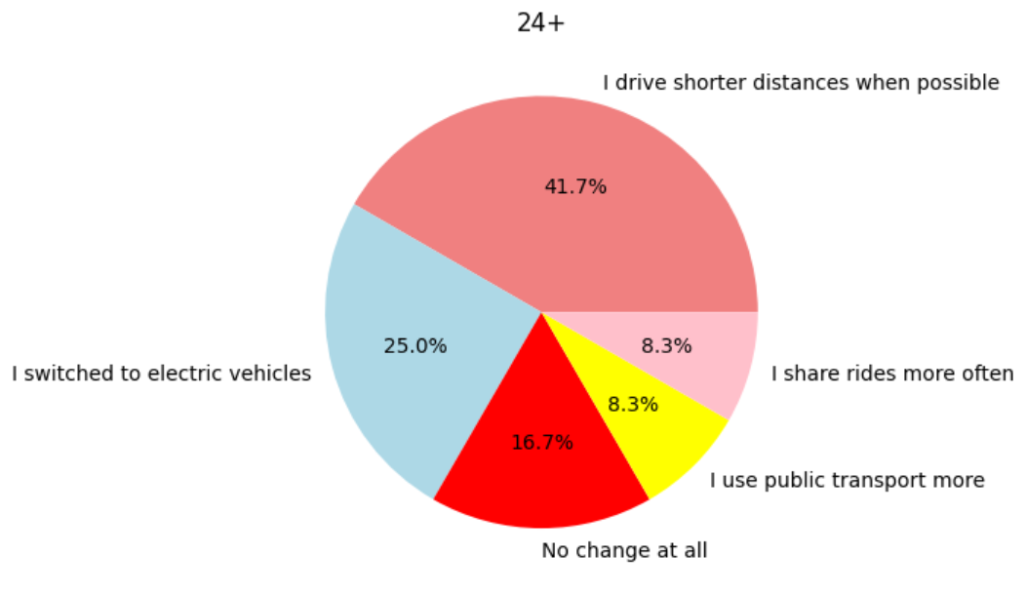

These pie charts compare how three different age groups (18-20, 21-23, and 24+) are changing their transportation habits. The data shows that as people get older, they tend to make more specific and permanent changes, like switching to electric vehicles.

From the data, we can see that:
(Age 18-20): This group is very balanced. They use public transport, share rides, and maintain their old habits at almost the same rate (24.1% each), The most popular change is driving shorter distances (27.6%).
(Age 21-23): This group shows a huge shift toward public transport (41.7%), which is the highest across all groups. (33.3%) focus on driving shorter distances, (25%) have made no changes to their habits.
(Age 24+): This group is the most proactive. ( 41.7% )drive shorter distances,(25%) have already switched to electric vehicles, a trend not seen in the younger groups ,They have the lowest "No change" rate (16.7%), meaning they are the most likely to adapt

This table shows the comparison clearly:
Category | 18-20 | 21-23 | 24+
Drive Shorter Distances | 27.6% | 33.3% | 41.7%
Public Transport | 24.1% | 41.7% | 8.3%
No Change at All | 24.1% | 25.0% | 16.7%
Electric Vehicles | 0% | 0% | 25.0%

Conclusion:

After analysing the data from 54 EUI students, we reject the null hypothesis. The results suggest that fuel price increases in Egypt influence transportation choices and driving habits.
the findings indicate that a significant portion of students have changed their driving behavior. Additionally, the relatively high reported financial burden across different spending levels suggests that rising fuel costs are having a noticeable impact on students.

Overall, the data indicates that fuel price changes are associated with adjustments in commuting behavior, such as driving shorter distance or increasing the use public transportation.

Any potential issues

- Sample Size and Accuracy: While 54 responses provided good insights, a larger sample size would have been more accurate and would have further reduced the margin of error. A bigger sample would help ensure that our findings better represent the entire university population and provide more stable results.

- Lack of Age Variety: Our study was limited to the 18–24 age group. Since all respondents are university students, the results don't show how older individuals or professionals who might have different financial responsibilities react to the changes in fuel prices. This lack of variety in ages means the findings cannot be generalized to the entire population of Egypt.

- Data Accuracy and Reliability: Some of the collected data might not be perfectly accurate. as some respondents may provide estimated figures or exaggerated answers These inaccuracies can slightly affect the overall findings, suggesting that more verification of the data would be needed to be more precise and accurate

- Sampling Bias: Because we used Convenience Sampling within the EUI community, the data might be biased toward a specific social and economic group. People in different geographic areas or with different income levels might face different challenges that were not captured in this study.

